Project Description  The Defense Logistics Agency (DLA) Aviation in coordination with the Air Force and the Office of the Assistant Secretary of Defense for Sustainment (OASD(S)) established a limited field demonstration project to evaluate synthetic biobased motor oil for use in non-tactical Department of Defense (DoD) and federal agency vehicles with gasoline powered engines.  The integration of renewable, biobased motor oils (minimum of 25% biobased content) will provide a sustainable alternative and reduce dependency on foreign oil while providing new markets for domestically produced agricultural products.  Organizations  - The Defense Logistics Agency (DLA) Aviation  - Air Force  - Office of the Assistant Secretary of Defense for Sustainment (OASD(S))  Project Timeline  2016-2018 18 months  Contact INformation  Biosynthetic Technologies  6320 Intech Way  Indianapolis, IN 46278  Phone: 317-556-1050  E-mail: info@biosynthetic.com  For more information please contact Jake Bredsguard at jbredsguard@biosynthetic.com  Product Info/Ordering  www.biosynthetic.com | Project Details  Department of Defense Trialed Biosynthetic Technology’s Biobased Motor Oil in a Demonstration.  The Defense Logistics Agency (DLA) Aviation in coordination with the Air Force and the Office of the Assistant Secretary of Defense for Sustainment (OASD(S)) established a limited field demonstration project to evaluate synthetic biobased motor oil for use in non-tactical Department of Defense (DoD) and federal agency vehicles with gasoline powered engines. The integration of renewable, biobased motor oils (minimum of 25% biobased content) will provide a sustainable alternative and reduce dependency on foreign oil while providing new markets for domestically produced agricultural products.  Before biobased motor oils can be fully implemented by the DoD and federal agencies, their performance needed be proven to meet government requirements and end user needs. The project team coordinated with DoD and federal agency personnel for data collection during the approximate 18 month demonstration period.  The Biosynthetic Technologies biobased synthetic motor oils have the American Petroleum Institute (API) certification and are derived from renewable base oils and offer drop in compatibility. The candidate biobased motor oils were demonstrated in vehicles at installations and facilities representing various climate conditions and vehicle duty cycles of the Military Departments and federal agencies. Oils samples were taken periodically from the demonstration vehicles for analysis. The demonstrated biobased full synthetic motor oils were found to meet or exceed the DoD and federal agencies performance requirements. The sustainable products will provide mission support and enhance operational readiness. This successful pilot facilitated the establishment of new National Stock Numbers (NSNs) for the sustainable/biobased products, making them available for DoD and federal agency procurement.  The DoD installations and Federal Agency facilities participating in the demonstration include:  - Air Force: Fairchild Air Force Base (AFB); Luke AFB, Malmstrom AFB; and Seymour-Johnson AFB  - Army: Fort Irwin  - Navy: Naval Air Station Lemoore  - Department of Homeland Security (DHS) Federal Law Enforcement Training Center (FLETC)  - National Aeronautics and Space Administration (NASA): Kennedy Space Center, Langley Research Center, Armstrong Flight Research Center and White Sands Test Facility  - United States Postal Service (USPS)  - The USAF 441st Vehicle Support Chain Operations Squadron (VSCOS) provided access to AF vehicles in various climate regions  Biosynthetic® Technologies manufactures a revolutionary new class of biobased synthetic compounds called Estolides that are made from organic fatty acids found in various bio-derived oils. These highly functional biosynthetic oils have numerous uses in lubricant, automotive, marine, pharma and personal care applications and can be used as the primary base oil of a formulation, a component of a base oil co-blend, or even as an additive. In addition to their high-performance properties, these renewable oils are biodegradable and nontoxic. Biosynthetic Technologies strives to make their mark on the world by delivering innovations for a sustainable future. For more information about Biosynthetic™ Technologies, please visit www.biosynthetic.com and follow us on LinkedIn.
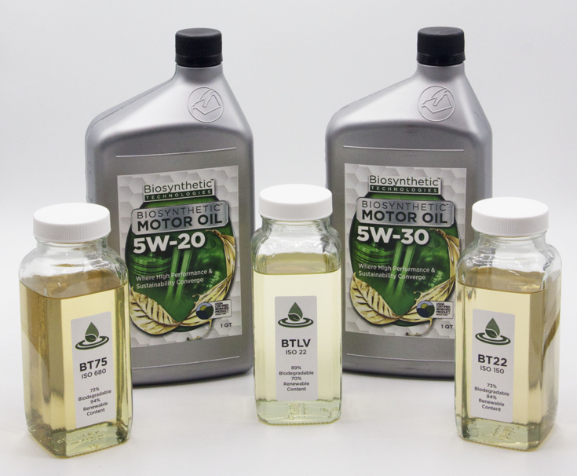
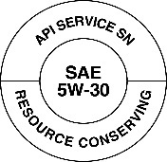
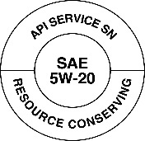
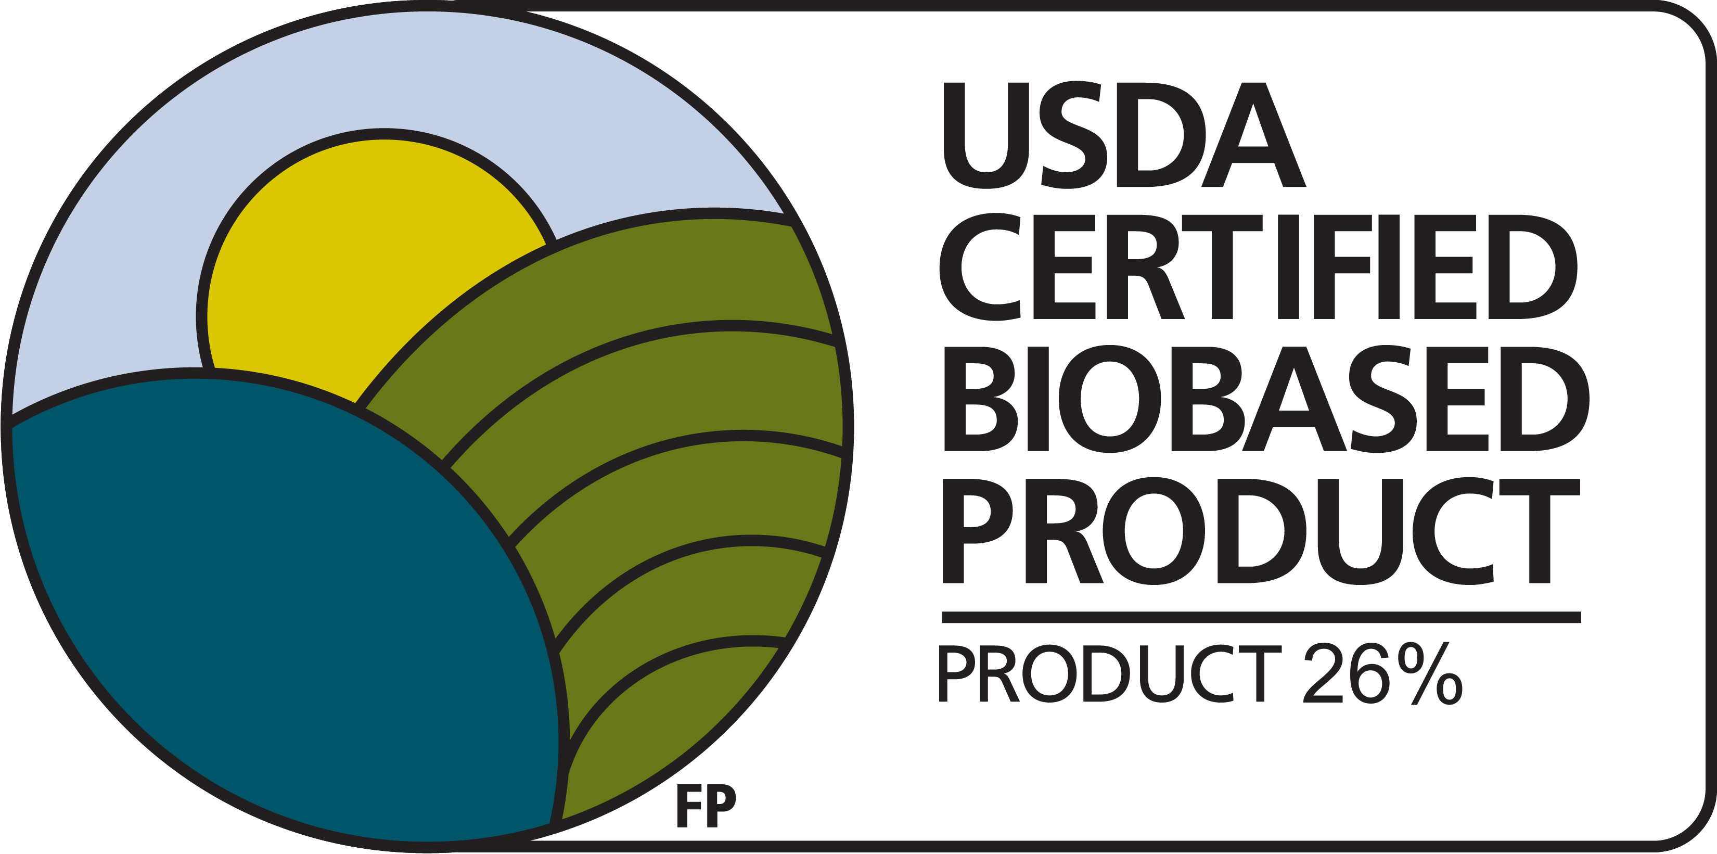
- Approved by the American Petroleum Institute (API)
- API SN-RC certification for 5W-20 and 5W-30 motor oil
  - 5W-20 and 5W-30 grades represent 79% of all motor oil sold in the U.S.
COMING SOON!
Coming Soon

